Cara Setting email outlook iforce.co.id
- Tools > Account Settings -> Tab Email >New
- Choose Email Service > Next
Pilih Microsoft Change, POP3, IMAP, or HTTP > Next
- Pilih Manually configure server setting or additional server types > Next
- Pilih Internet Email > Next
- Masukan Data :
User Information
Your Name : <ketik nama>
Email Address : <ketik alamat email iforce>
Server Information
Account Type : POP3
Incoming mail server : Sh2.cbncloud.co.id : 995 SSL
Outgoing mail server : Sh2.cbncloud.co.id : 465 SSL
Login Information
User Name : <ketik alamat email iforce>
Password : <ketik password>
- Pilih more settings
- Pada tab outgoing server
- Pilih my outgoing server (SMTP) requires aunhentication > log on using di klik
- Klik lagi
- Pada tab Advanced
- Incoming server (POP3) : 110
- Pilih This server requires an encrypted connection (SSL),
- OUTGOING SERVER (SMTP) : 465,
- Use the following type of encrypted connection : SSL
- Klik Oke
- Klik button Test Account Setting
- Next > Finish

- Tools > Account Settings -> New
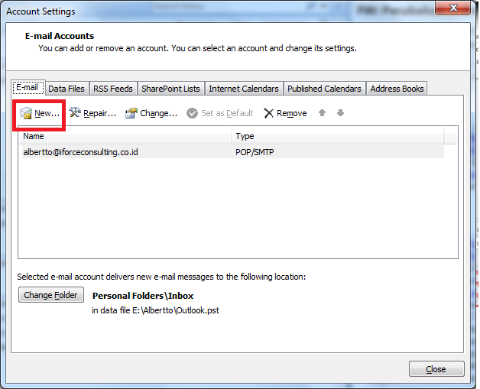
- Microsoft Exchange, POP3, IMAP, or HTTP -> Next
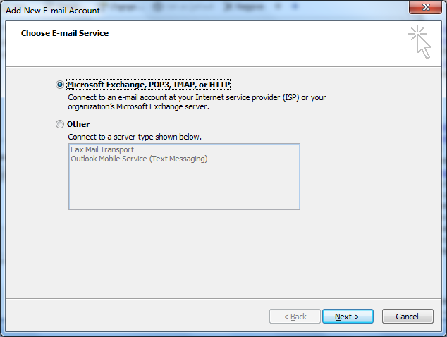

- Manually configure, Next
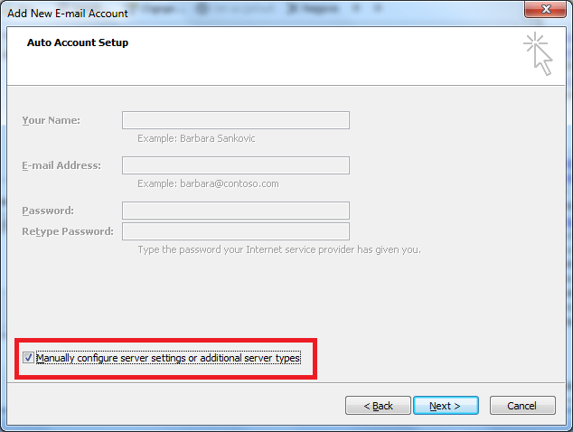
- Internet Email, Next
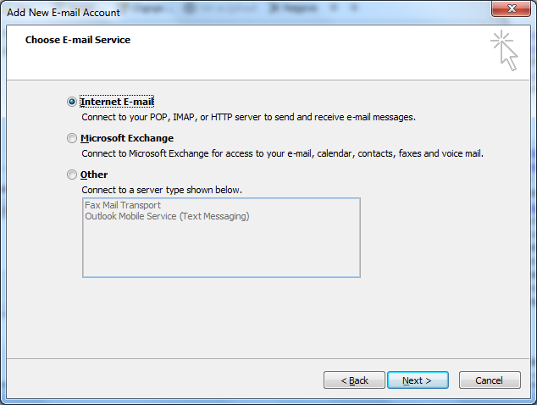

- Setting seperti gambar -> more settings
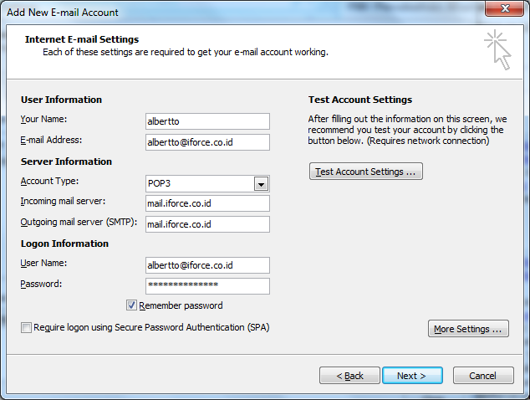
SETTING MAIL IFORCE
Incoming mail server : sh2.cbncloud.co.id : 995 SSL
Outgoing : sh2.cbncloud.co.id : 465 SSL
INTERNET E-mail Setting
Incoming server (POP 3) : 110
Outgoing server (SMTP: 465
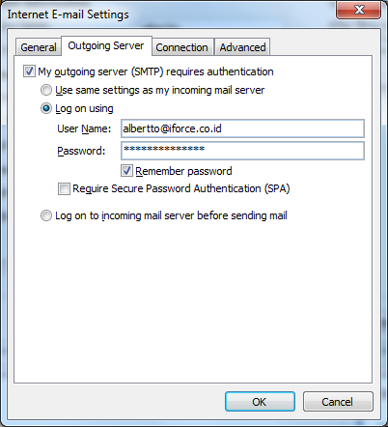
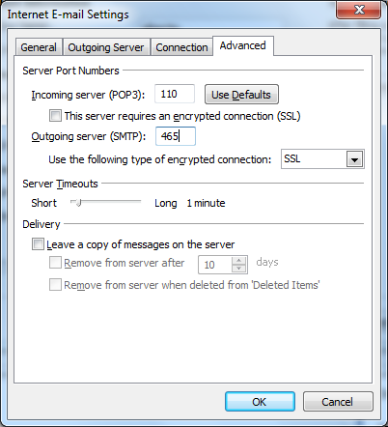
- OK -> Next -> Finish
- Klik pada account baru -> Set as Default.
